Critical Review of Deep Reinforcement Learning for Dynamic Task Offloading in the 5G Edge-Cloud Continuum
Syahril Fahmi
Course: Mobile Communications and Cloud Computing
Southern Taiwan University of Science and Technology, Tainan, Taiwan

Abstract—This report reviews the paper “Deep Reinforcement Learning techniques for dynamic task offloading in the 5G edge-cloud continuum” by Nieto et al., published in the Journal of Cloud Computing in 2024. The paper addresses where an Internet of Things (IoT) device should execute each task: locally, on a Multi-access Edge Computing (MEC) server, or in the cloud. The authors model the problem as a Markov decision process and let every device run its own Actor-Critic agent, with quality of experience (QoE) defined by energy use under a latency deadline. This report summarizes the motivation, system model, learning formulation and evaluation, then gives a critical assessment of the paper’s contributions and limitations, and relates them to mobile communications and cloud computing.
Index Terms—task offloading, multi-access edge computing, 5G, deep reinforcement learning, actor-critic, edge-cloud continuum.
I. INTRODUCTION
IoT devices such as sensors, wearables and augmented reality (AR) headsets generate tasks that often exceed the computing power or battery budget of the device. Offloading these tasks to a more powerful machine is the standard response. Classic cloud computing offers large capacity but is physically far from the user, so the round-trip delay can violate the deadlines of latency-critical applications. MEC places servers next to the 5G base station and reduces delay, but these servers have limited capacity and can become congested or unavailable [1], [2].
The choice between local, edge and cloud execution therefore depends on the task, the wireless channel, the battery level and the current load of every server. These quantities change from one moment to the next, so a fixed rule cannot be optimal. Nieto et al. [1] study this decision problem and propose a distributed deep reinforcement learning (DRL) solution in which each user equipment (UE) learns its own offloading policy. This report explains that work and evaluates it critically.
The remainder of the report is organized as follows. Section II gives background and the research gap. Section III describes the system model. Section IV presents the DRL formulation. Section V summarizes the evaluation. Section VI offers a critical analysis and Section VII concludes.
II. BACKGROUND AND RESEARCH GAP
A. Computation offloading in MEC
Surveys of MEC describe offloading as a joint problem of communication and computation: the time and energy to send data over the radio link must be weighed against the time and energy saved by using a faster processor [2], [3]. Solutions in the literature include heuristics, metaheuristics, convex optimization and, more recently, machine learning.
B. Why reinforcement learning
Supervised learning needs a labeled data set that covers all environment states, which is unrealistic for a system whose load and channel conditions vary continuously. Reinforcement learning (RL) instead learns from interaction with the environment [4]. Deep RL uses neural networks to approximate the policy or value function and can therefore handle large state spaces [5].
C. Gap identified by the authors
Nieto et al. argue that heuristic and metaheuristic approaches adapt poorly to dynamic conditions, and that centralized versions scale badly. Many ML-based approaches are centralized, which creates network overhead and privacy concerns, and several ignore the cloud tier or model only a single task type. The authors state that their work is the only ML-based distributed approach that considers different task classes together with dynamic network behavior and three execution options [1]. This is the authors’ own claim about the literature and is not independently verified here.
III. SYSTEM MODEL
A. Network architecture
The model has three tiers, shown in Fig. 1. Multiple UEs connect over a wireless link to a base station (BS). A MEC server is co-located with the BS, so the UE-to-MEC distance equals the UE-to-BS distance. A cloud server is reached from the BS through an optical fiber link. Each task can be executed locally (α = 0), on the MEC server (α = 1) or in the cloud (α = 2).
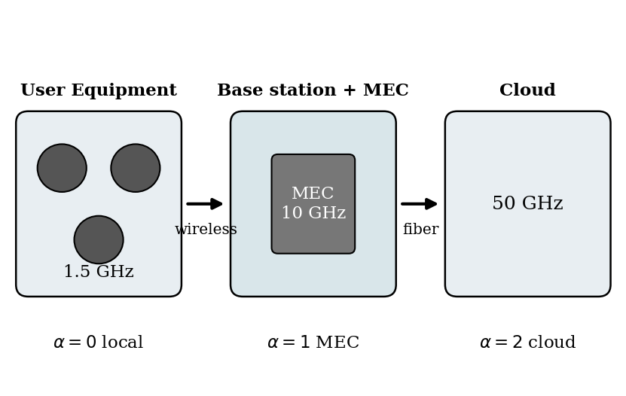
Fig. 1. Three-tier architecture and the three execution options.
B. Task model
A task is described by its data size D, the number of CPU cycles φ it requires, and its maximum tolerated delay T_req. Tasks belong to one of three classes: delay-sensitive (for example smart sensors), energy-sensitive (for example AR) and insensitive (for example smart-grid analytics). Table I lists the parameter ranges used in the paper.
TABLE I
TASK CLASSES USED IN THE EVALUATION [1]
Class | Data size | CPU cycles | Deadline
1 Delay-sens. | 50-100 KB | 0.5-1 G | 0.01-0.05 s
2 Energy-sens. | 100-500 KB | 1-2 G | 0.05-0.5 s
3 Insensitive | 500-2000 KB | 2-5 G | 0.5-2 s

C. Latency model
For local execution the delay is the number of cycles divided by the CPU frequency available at the UE:
t_local = φ / f_UE (1)
For offloading, the data first cross the wireless link at a rate given by the Shannon capacity, R = W log2(1 + p h / N0), where W is the bandwidth, p the transmit power, h the channel gain and N0 the noise power. The channel gain follows the 3GPP indoor path-loss model with shadow fading [6]. The MEC delay is transmission plus processing:
t_MEC = D / R + φ / f_MEC (2)
The cloud path adds fiber transmission and the propagation delay over the BS-to-cloud distance, twice for the round trip:
t_cloud = D / R + t_fiber + 2L / v + φ / f_cloud (3)
D. Energy model
Local energy grows with the square of the CPU frequency, e_local = κ f² φ, where κ is a chip-dependent coefficient. When a task is offloaded, the UE spends energy only on transmission:
e_off = p · D / R (4)
The fiber link adds no UE energy, so MEC and cloud offloading have the same energy cost for the device. This means the choice between them is decided by latency and server availability rather than by battery.
IV. DRL FORMULATION AND ALGORITHM
A. Markov decision process
Every UE is an independent, non-cooperative agent (Fig. 2). At time step i the state is a six-element vector containing the UE battery level, the free resources at the UE, MEC and cloud, the channel gain, and the class of the arriving task. The action α is one of {0, 1, 2}. The reward is the QoE: if the task meets its deadline, the reward is the negative energy spent divided by the battery capacity B; otherwise it is a fixed penalty η = −100:
QoE = −e / B (deadline met); QoE = η (missed) (5)
The objective is to maximize the sum of QoE over the episode. Normalizing energy by battery capacity makes the reward reflect how much of the remaining life a decision consumes.
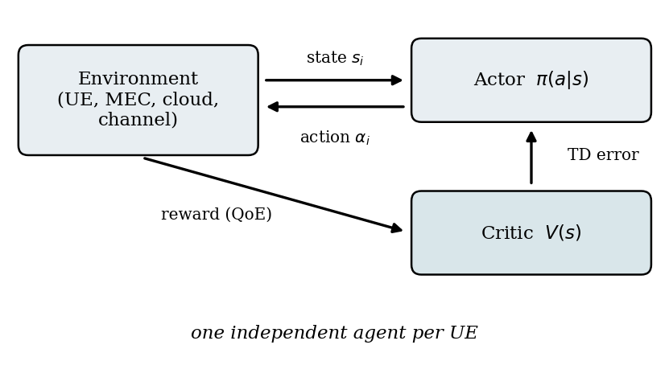
Fig. 2. Per-UE Actor-Critic agent interacting with the environment.
B. Actor-Critic agent
The agent uses an Actor-Critic architecture [7]. The actor network has two hidden layers of 256 neurons with TanH activations and a softmax output over the three actions. The critic has the same hidden structure with a linear output that estimates state value. The learning rates are 10⁻⁵ for the actor and 10⁻⁴ for the critic, the discount factor is 0.99, weights use LeCun initialization and training uses the Adam optimizer with temporal-difference updates. The proposed variant keeps actor and critic as separate networks; it is compared with a variant that shares hidden layers.
V. EXPERIMENTAL EVALUATION
A. Setup
The environment was implemented in Python with TensorFlow and Gymnasium. It contains one cloud server, one MEC server and several UEs. Table II lists the main parameters.
TABLE II
MAIN ENVIRONMENT PARAMETERS [1]
Parameter | Value
UE battery capacity | 10,000 mJ
UE / MEC / cloud CPU | 1.5 / 10 / 50 GHz
UE transmit power | 200 mW
Noise power | −80 dBm
UE-BS distance | 30-150 m
BS-cloud distance | 50 km
Fiber capacity | 10 Tbps
Missed-deadline penalty | −100

B. Scenarios and baselines
Two scenarios test adaptation. In the first, the MEC server is unavailable during two time windows, and the workload is 90% Class 1, 90% Class 2, 90% Class 3, or a mix. In the second, the MEC server is available but the wireless link fails for part of the run. Static baselines always execute locally, always on MEC, or always in the cloud. Dynamic baselines are random selection, the joint-network Actor-Critic and a Double Dueling DQN (DDDQN) [8].
C. Results
The paper presents most results as QoE and battery curves over time rather than as summary tables, so Table III condenses the qualitative findings; exact values should be read from the figures in [1].
TABLE III
SUMMARY OF REPORTED OUTCOMES, SCENARIO 1 [1]
Workload | Static baselines | Proposed agent
90% Class 1 | Cloud worst; Local drains battery; MEC best while up | Best dynamic; adapts after MEC fails
90% Class 2 | Local worst; MEC and cloud similar | Slightly above joint-network AC
90% Class 3 | Local worst; MEC/cloud QoE near 0 | Keeps more battery; MEC then cloud
Mixed | MEC best static | Best QoE; DDDQN worst

Three observations stand out. First, no static policy is best everywhere: cloud fails delay-critical tasks, local execution wastes battery on heavy tasks, and MEC fails when the edge is down. Second, the proposed agents use MEC while it is available and shift to the cloud or local execution when it is not. Third, separating actor and critic networks gave slightly better results than sharing hidden layers, and DDDQN learned more slowly in the reported runs. In the communication-failure scenario the dynamic agents also adjusted their behavior and outperformed the static baselines.
VI. CRITICAL ANALYSIS
A. Contributions and strengths
The most useful contribution is the QoE definition, which turns a multi-objective problem (energy and deadline) into a single scalar reward that an RL agent can optimize. Making each UE an independent agent avoids a central controller, which reduces signaling overhead and keeps task information on the device. The model is also more realistic than many offloading studies because it includes a standard 3GPP channel model, a fiber backhaul with propagation delay, battery-normalized energy and three task classes. Finally, testing failure conditions is valuable, since practical edge systems must survive outages, not only average load.
B. Limitations
The authors acknowledge several limitations: tasks cannot be partitioned and have no dependencies, queues are simple first-in-first-out with completion inside one time slot, fast fading is assumed to average out, and scalability to many agents is not tested [1]. From the reviewer’s viewpoint, further concerns are as follows. The evaluation is simulation-only with two scenarios and a single MEC and cloud server, so contention among many UEs for the same MEC is not really studied even though the agents are non-cooperative and share it. Results are mainly curves without confidence intervals or repeated-seed statistics in the material reviewed, which makes the size of the advantage over DDDQN hard to judge. DDDQN may also be sensitive to hyperparameters that were not necessarily tuned as carefully as the proposed method. Finally, independent learners in a shared environment face a non-stationary problem because other agents change their policies, and the paper gives limited theoretical guarantees on convergence.
C. Relevance to mobile communications and cloud computing
The paper connects the two halves of the course. Its wireless part relies on Shannon capacity, path loss and shadow fading; its cloud part deals with server capacity, occupancy and the placement of computation along the edge-cloud continuum. It shows how radio conditions directly change where computation should run, which is a central design question for 5G and future 6G systems.
D. Future work
The authors suggest more complex environments, larger numbers of UEs, cloud-edge-device collaboration, and support for task dependencies and partial offloading [1]. Adding realistic mobility, multiple MEC servers with handover, and federated training across UEs would be natural next steps.
VII. CONCLUSION
Nieto et al. show that a distributed Actor-Critic agent on every device can learn to choose between local, MEC and cloud execution and can adapt when the edge server or the radio link fails. Within the simulated scenarios it achieves higher QoE and better battery use than fixed policies and a DDDQN baseline. The work is a solid step toward adaptive offloading, but stronger claims will need larger-scale, multi-UE and real-testbed evaluation.
REFERENCES
[1] G. Nieto, I. de la Iglesia, U. Lopez-Novoa, and C. Perfecto, “Deep Reinforcement Learning techniques for dynamic task offloading in the 5G edge-cloud continuum,” J. Cloud Comput., vol. 13, Art. no. 94, May 2024, doi: 10.1186/s13677-024-00658-0.
[2] Y. Mao, C. You, J. Zhang, K. Huang, and K. B. Letaief, “A survey on mobile edge computing: The communication perspective,” IEEE Commun. Surveys Tuts., vol. 19, no. 4, pp. 2322–2358, 4th Quart. 2017.
[3] P. Mach and Z. Becvar, “Mobile edge computing: A survey on architecture and computation offloading,” IEEE Commun. Surveys Tuts., vol. 19, no. 3, pp. 1628–1656, 3rd Quart. 2017.
[4] R. S. Sutton and A. G. Barto, Reinforcement Learning: An Introduction, 2nd ed. Cambridge, MA, USA: MIT Press, 2018.
[5] V. Mnih et al., “Human-level control through deep reinforcement learning,” Nature, vol. 518, no. 7540, pp. 529–533, 2015.
[6] 3GPP, “Study on channel model for frequencies from 0.5 to 100 GHz,” 3rd Generation Partnership Project, TR 38.901.
[7] V. R. Konda and J. N. Tsitsiklis, “Actor-critic algorithms,” in Advances in Neural Information Processing Systems 12, 1999, pp. 1008–1014.
[8] Z. Wang, T. Schaul, M. Hessel, H. van Hasselt, M. Lanctot, and N. de Freitas, “Dueling network architectures for deep reinforcement learning,” in Proc. ICML, 2016, pp. 1995–2003.

